From the Editor

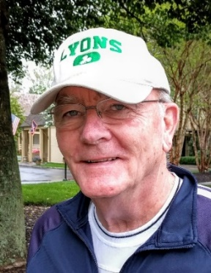
I offer a thankful welcome to Lori Lyons, the new editor of The Lyon’s Tale (LT). Readers may recall that it was Lori who won the Oldest Living Lyon(s) contest and who received one of our coveted t-shirts with the new LFA crest; she also recently wrote an article about the settlement of her Lyons line in Louisiana. In addition to her distinguished career as a sports writer for The Times-Picayune, she is a blogger, an accomplished amateur genealogist, and an author; her book, Adopting in America: The Diary of a Mom in Waiting severely depleted my box of tissues.

More Lyon(s) Baseball
In the six years that I have been editor of the LT, no article has evoked more reader response than Barry Pavelec’s article about the Lyon(s) of major league baseball. In this issue, Barry offers Part II of his three-part series. Barry, my pal and Rutgers University School of Journalism classmate, deserves a special acknowledgment for his many contributions to the LT. His research skill and storytelling prowess gave us insights to the extraordinary life of Bud Lyon, who followed a showgirl to China in the 1930s, and to the remarkable life of actor and patriot Ben Lyon and Ben’s family.

More thanks
While thanking Barry, I can’t forget Michael Hewitt who has contributed so many articles to the LT based on the research he did for his book, A Most Remarkable Family. Thanks Mike. Sam Watson, my army pal—he was Lieutenant Watson then and later Professor Watson—deserves a large measure of thanks for his informative and entertaining articles about the people named Lyons who touched his life and for his two poems, one of which was the very first poem published in the LT.

Direct Lyon(s) Lineages
In this issue, you will find four DLLs, including one from Donald Boatright who also gives us a profile of Reverend Richard Lyon.

Final thanks
Though I was an older but new guy to the leadership of the LFA, I benefitted from the guidance and encouragement of president Mike, secretary Porter, and historian Bruce, the three foundation pillars of the modern LFA. They also contributed articles based on their research and experience. Thanks mates.

Poems
A few years ago, the LT started carrying poems that had a familial or generational theme. In this issue, you will find two public domain poems. Both meet the standard to qualify under the theme requirement, but on the up-down poetry scale, they are both downers. Though the Scottish poet Thomas Campbell wrote, “To live in hearts we leave behind is not to die,” Henry Wadsworth Longfellow carries the memory of his wife who died after a fire in their home as a cross, and Edna St. Vincent Millay can’t quite remember why life must go on after the death of a spouse. It is not my intent to close this issue with a depressing thought but to herald the enormity of love for family.

Bye, Bill

